|  |  |
| --- | --- |
|  | **DEPARTMENT OF COMPUTER SYSTEMS ENGINEERING**  **MEHRAN UNIVERSITY OF ENGINEERING & TECHNOLOGY, JAMSHORO**  **Database Management Systems (4th Semester) 18CS**  **Lab Experiment 5** |

|  |  |  |  |
| --- | --- | --- | --- |
| **Roll No:** |  | **Date of Conduct:** |  |
| **Submission Date:** |  | **Grade Obtained:** |  |

|  |  |  |  |
| --- | --- | --- | --- |
| **Problem Recognition (0.3)** | **Completeness & accuracy (0.4)** | **Timeliness (0.3)** | **Score (1.0)** |
|  |  |  |  |

**Objective**: **To use Single row functions in SQL queries.**

**Tools: MySql, Oracle.**

**Introduction:**

**Single Row functions** - Single row functions are the one who work on single row and return one output per row. For example, length and case conversion functions are single row functions.

**Single row functions**

Single row functions can be character functions, numeric functions, date functions, and conversion functions. Note that these functions are used to manipulate data items. These functions require one or more input arguments and operate on each row, thereby returning one output value for each row. Argument can be a column, literal or an expression. Single row functions can be used in SELECT statement, WHERE and ORDER BY clause. Single row functions can be -

* **General functions** - Usually contains NULL handling functions. The functions under the category are NVL, NVL2, NULLIF, COALESCE, CASE, DECODE.
* **Case Conversion functions** - Accepts character input and returns a character value. Functions under the category are UPPER, LOWER and INITCAP.
  + UPPER function converts a string to upper case.
  + LOWER function converts a string to lower case.
  + INITCAP function converts only the initial alphabets of a string to upper case.
* **Character functions** - Accepts character input and returns number or character value. Functions under the category are CONCAT, LENGTH, SUBSTR, INSTR, LPAD, RPAD, TRIM and REPLACE.
  + CONCAT function concatenates two string values.
  + LENGTH function returns the length of the input string.
  + SUBSTR function returns a portion of a string from a given start point to an end point.
  + INSTR function returns numeric position of a character or a string in a given string.
  + LPAD and RPAD functions pad the given string Upto a specific length with a given character.
  + TRIM function trims the string input from the start or end.
  + REPLACE function replaces characters from the input string with a given character.
* **Date functions** - Date arithmetic operations return date or numeric values. Functions under the category are MONTHS_BETWEEN, ADD_MONTHS, NEXT_DAY, LAST_DAY, ROUND and TRUNC.
  + MONTHS_BETWEEN function returns the count of months between the two dates.
  + ADD_MONTHS function add 'n' number of months to an input date.
  + NEXT_DAY function returns the next day of the date specified.
  + LAST_DAY function returns last day of the month of the input date.
  + ROUND and TRUNC functions are used to round and truncates the date value.
* **Number functions** - Accepts numeric input and returns numeric values. Functions under the category are ROUND, TRUNC, and MOD.
  + ROUND and TRUNC functions are used to round and truncate the number value.
  + MOD is used to return the remainder of the division operation between two numbers.

**Lab Task**

**1. Display the employee name and their annual salary including commission amount. If the**

**Commission is null replace it with 0.**

**Task:**

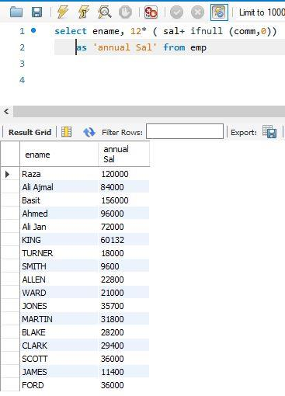

**2. Display Employee’s name with the first letter capitalized and all other letters lowercase and**

**the length of their name, for all employees whose name starts with J, A, or M. Give each column**

**appropriate names.**

**Task:**

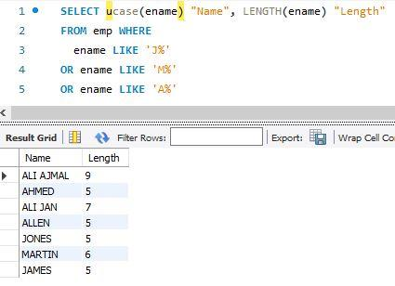

**3. Display the name, hiredate, and day of the week on which the employee started. Label the**

**Column First Day.**

**Task:**

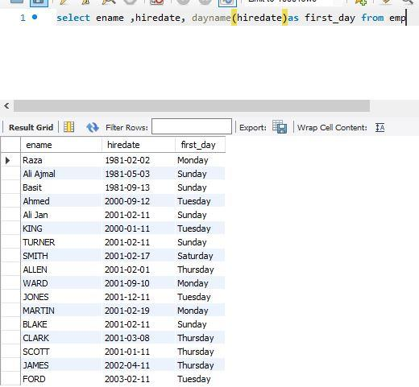

**4. For each employee, display the employee name and calculate the number of months between**

**today and the date the employee was hired. Label the column MONTHS_WORKED. Order the**

**result by the number of months employed. Round the number of months up to the closest whole**

**number.**

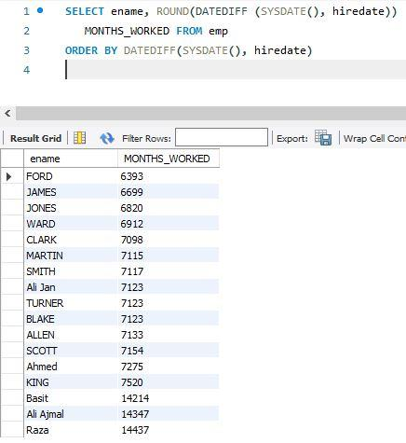**Task:**

**5. Display the Employee number, name, salary, and salary increase by 15% expressed as a whole number. Label the column New Salary.**

**Task:**

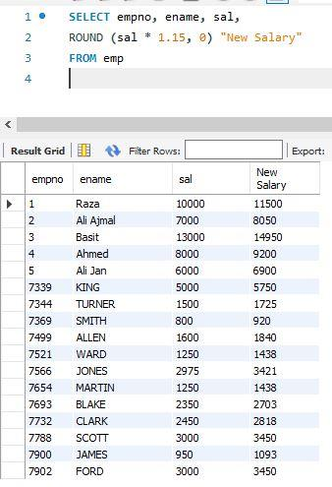

**6. Display the employee name, hiredate, and salary review date, which is the first Monday**

**after six months of service. Label the column REVIEW. Format the dates to appear in the format similar to “Sunday, the seventh of September, 1981”.**

**Task:**

